

**Assignment Title**

University

Year 2023

**First Assignment**

Labheshwar| 2K20/CSM/50

Visual Programming (C#)

Date of Submission: March 11, 2023

Academic Year: 2023

Institute of Mathematics & Computer Sience

**University of Sindh Jamshoro**

**CODE**

// Code by Labheshwar

// Roll Number (2K20/CSM/50)

// Description: CodeLab by Labesh is an bootcamp (online courses)

// that aims to provide essential courses at reasonable prices

using System;

using System.Collections.Generic;

using System.ComponentModel;

using System.Data;

using System.Drawing;

using System.Linq;

using System.Text;

using System.Threading.Tasks;

using System.Windows.Forms;

namespace _2FormAssignment2

{

public partial class Form1 : Form

{

public Form1()

{

InitializeComponent();

}

private void headerLabel_Paint(object sender, PaintEventArgs e)

{

ControlPaint.DrawBorder(e.Graphics,

headerLabel.DisplayRectangle, Color.Lime, ButtonBorderStyle.Solid);

}

private void signInButton_Click(object sender, EventArgs e)

{

if (studentIdTextBox.Text != "" && nameTextBox.Text != "")

{

welcomeRichTextBox.Text = "Welcome Student #"

+ studentIdTextBox.Text

+ Environment.NewLine + nameTextBox.Text;

studentIdLabel.Visible = false;

studentIdTextBox.Visible = false;

nameLabel.Visible = false;

nameTextBox.Visible = false;

}

}

private void printButton_Click(object sender, EventArgs e)

{

printForm1.PrintAction = System.Drawing.Printing.PrintAction.PrintToPreview;

printForm1.Print();

}

private void exitButton_Click(object sender, EventArgs e)

{

this.Close();

}

private void webDesRadioButton_CheckedChanged(object sender, EventArgs e)

{

if (imageVisibleCheckBox.Checked)

{

coursesPictureBox.Image = _2FormAssignment2.Properties.Resources.webdes;

promotionsTextBox.Text =

"Learn essential tech skills like HTML, CSS + Bootstrap and JS) at the cheapest price";

}

}

private void webDevRadioButton_CheckedChanged(object sender, EventArgs e)

{

if (imageVisibleCheckBox.Checked)

{

coursesPictureBox.Image = _2FormAssignment2.Properties.Resources.mern;

promotionsTextBox.Text = "Learn advance full stack web development at cheapest";

}

}

private void winFormRadioButton_CheckedChanged(object sender, EventArgs e)

{

if (imageVisibleCheckBox.Checked)

{

coursesPictureBox.Image = _2FormAssignment2.Properties.Resources.winform;

promotionsTextBox.Text =

"Learn Visual Programming in C# and become a windows developer";

}

}

private void dotNetRadioButton_CheckedChanged(object sender, EventArgs e)

{

if (imageVisibleCheckBox.Checked)

{

coursesPictureBox.Image = _2FormAssignment2.Properties.Resources.dotnet;

promotionsTextBox.Text =

"Learn the most demanding skill in the market at absolute cheap price";

}

}

private void javaDevRadioButton_CheckedChanged(object sender, EventArgs e)

{

if (imageVisibleCheckBox.Checked)

{

coursesPictureBox.Image = _2FormAssignment2.Properties.Resources.javadev;

promotionsTextBox.Text = "Learn the most high paid skill at the cheapest price";

}

}

}

}

|  |  |
| --- | --- |
| OBJECTS AND PROPERTIES |  |
| **Object** | **Property** | **Setting** |
| **headerLabel** | BackColor  ForeColor  BorderStyle  Font  FontStyle  FontSize  Text | **Black**  **Lime**  **FixedSingle**  **Corbel**  **Bold**  **24**  **CodeLab By Labesh** |
| **webDesRadioButton** | Font  FontSize  ForeColor  Text | **Corbel**  **10pt**  **Lime**  **Web Designing** |
| **webDevRadioButton** | Font  FontSize  ForeColor  Text | **Corbel**  **10pt**  **Lime**  **Web Development (MERN Stack)** |
| **winFormRadioButton** | Font  FontSize  ForeColor  Text | **Corbel**  **10pt**  **Lime**  **Windows Form Developer** |
| **dotNetRadioButton** | Font  FontSize  ForeColor  Text | **Corbel**  **10pt**  **Lime**  **.NET Developer** |
| **javaDevRadioButton** | Font  FontSize  ForeColor  Text | **Corbel**  **10pt**  **Lime**  **Java (Spring) Developer** |
| **coursesPictureBox** | SizeMode | **Stretch** |
| **imageVisibleCheckBox** | BackColor  Cursor  Font  FontSize  ForeColor  Text | **Lime**  **Hand**  **Corbel**  **14pt**  **Black**  **Image Visible** |
| **nameLabel** | Font  FontSize  ForeColor  Text | **Corbel**  **12pt**  **WhiteSmoke**  **Name** |
| **studentIdLabel** | Font  FontSize  ForeColor  Text | **Corbel**  **12pt**  **WhiteSmoke**  **Student ID** |
| **welcomeRichTextBox** | BackColor  BorderStyle  Font  FontSize  ForeColor | **Lime**  **Fixed3D**  **Corbel**  **20pt**  **Black** |
| **promotionsTextBox** | BackColor  BorderStyle  Font  FontSize  FontColor | **Black**  **FixedSingle**  **Corbel**  **12pt**  **Lime** |
| **signInButton** | BackColor  Cursor  Font  FontSize  FontColor  Text | **Lime**  **Hand**  **Corbel**  **12pt**  **Black**  **Sign In** |
| **printButton** | BackColor  Cursor  Font  FontSize  FontColor  Text | **Lime**  **Hand**  **Corbel**  **12pt**  **Black**  **Print** |
| **exitButton** | BackColor  Cursor  Font  FontSize  FontColor  Text | **Lime**  **Hand**  **Corbel**  **12pt**  **Black**  **Exit** |
| **Form1** | WindowState | **Maximized** |
| **coursesGroupBox** | BackgroundImage  Font  FontSize  FontColor Text | **Stretch**  **Corbel**  **12pt**  **WhiteSmoke**  **COURSES WE OFFER** |

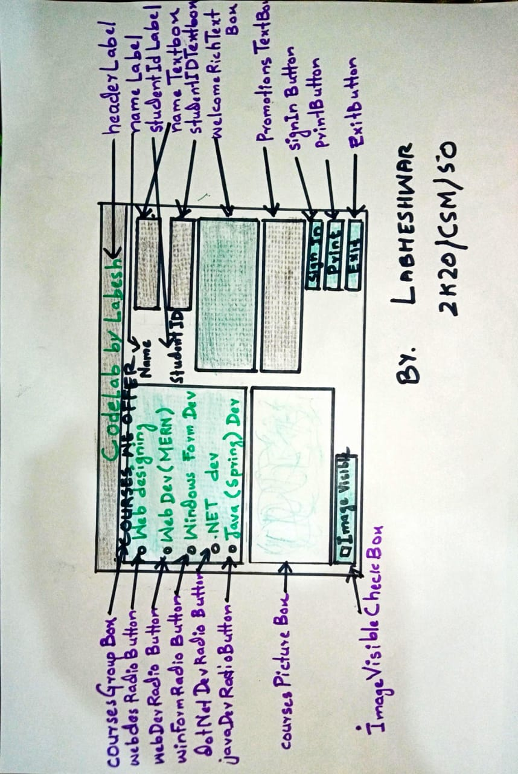

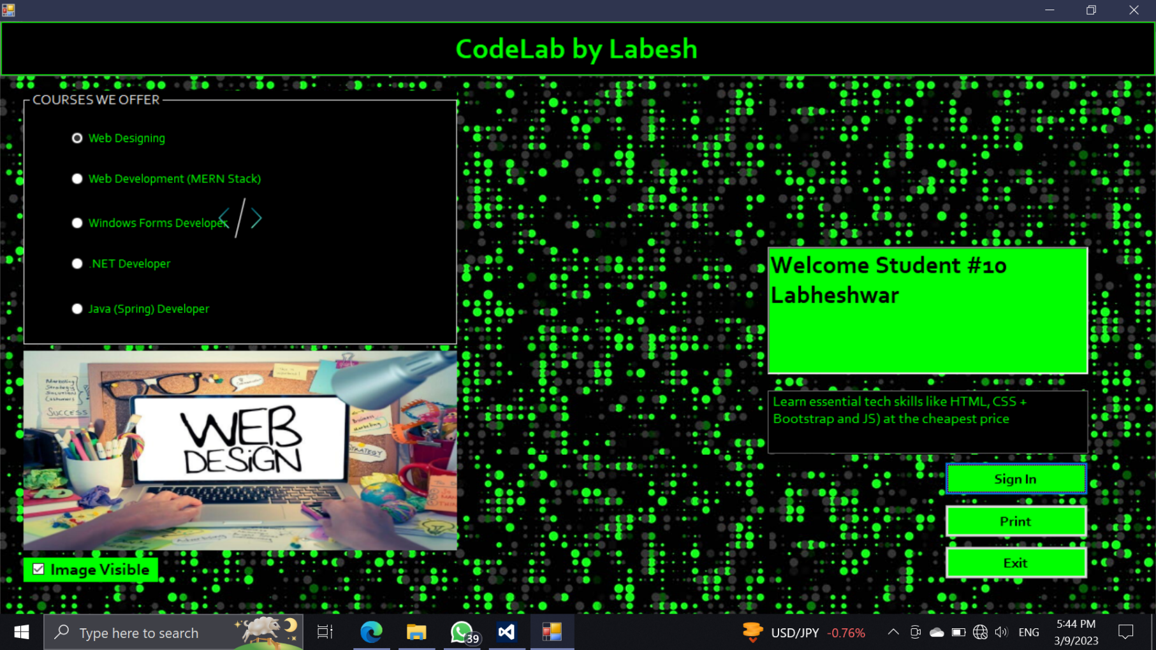**Graphical User Interface**